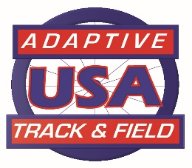
Adaptive Track and Field, USA
2021 Board of Directors

The 2021 ATFUSA Board Board Term
(** term ends in 2021)

Philip Galli Chairman / Long Distance Racing Chair 2021-2024
Jerry Clayton Vice-Chair – Officials/Jr ** 2018-2021
Tom Southall Treasurer 2020-2023
Jessica Cloy Secretary 2019-2022
Pam Carey Member at Large (MAL) – High School ** 2018-2021
Pam Chiavaroli MAL – 2019-2022
Brian Seamann Athlete Representative 2020-2023
Teresa Skinner MAL – High School/Coaching 2020-2023
Cindy Latham MAL – Field Coaching 2020-2023
Randy Chiavaroli MAL – Field Chair 2021-2024
Jim Shrunk MAL – Track Chair/Record Chair 2021-2024
Denise Hutchens MAL – Classification Chair 2019-2022
Frank Anzaldi MAL – T20 Chair 2019-2022

2022-2025
CANDIDATE SLATE
Jerry Clayton - Vice Chair
Pam Carey - MAL

