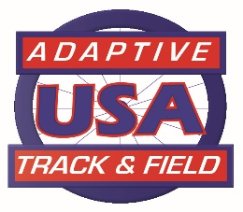
Adaptive Track and Field, USA
2020 Board of Directors

The 2020 ATFUSA Board Board Term
(** term ends in 2020)

Philip Galli Chairman / Long Distance Racing Chair ** 2017-2020
Jerry Clayton Vice-Chair – Officials/Jr 2018-2021
Tom Southall Treasurer 2020-2023
Jessica Cloy Secretary 2019-2022
Pam Carey Member at Large (MAL) – High School 2018-2021
Pam Chiavaroli MAL – Records 2019-2022
Brian Seamann Athlete Representative 2020-2023
Teresa Skinner MAL – High School 2020-2023
Cindy Latham MAL – Field Coaching 2020-2023
Randy Chiavaroli MAL – Field Chair ** 2017-2020
Paul Johnson MAL – Track Chair ** 2017-2020
Denise Hutchens MAL – Classification Chair 2019-2022
Frank Anzaldi MAL – T20 Chair 2019-2022

2021-2024
CANDIDATE SLATE
Philip Galli - Chair
Jim Shrunk - MAL
Randy Chivavaroli - MAL

